Lab: Unit Testing Lists
Submit your solutions here: https://judge.softuni.org/Contests/5197/Unit-Testing-Lists-Lab

Unit Test List: Gauss Trick
For the first list problem, test a method which takes in a list of integers and sums each pair of numbers from the beginning and end.
The method is found in the GaussTrick.cs file:
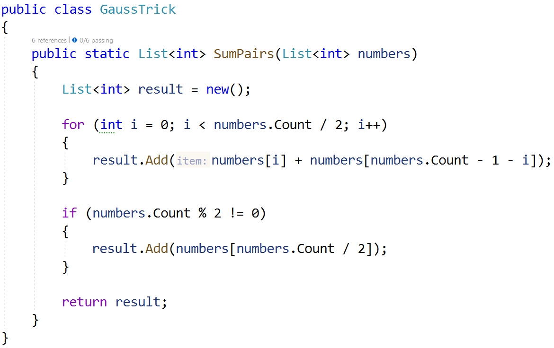
Example: If we have the numbers 1 2 3 4 5, the method will first sum 1 and 5, then 2 and 4, and finally because the list is odd it will append 3 to the result. The final list will be 6 6 3.
In the test file GaussTrickTests.cs you are given 6 tests. One is finished, two are unfinished and three are empty:
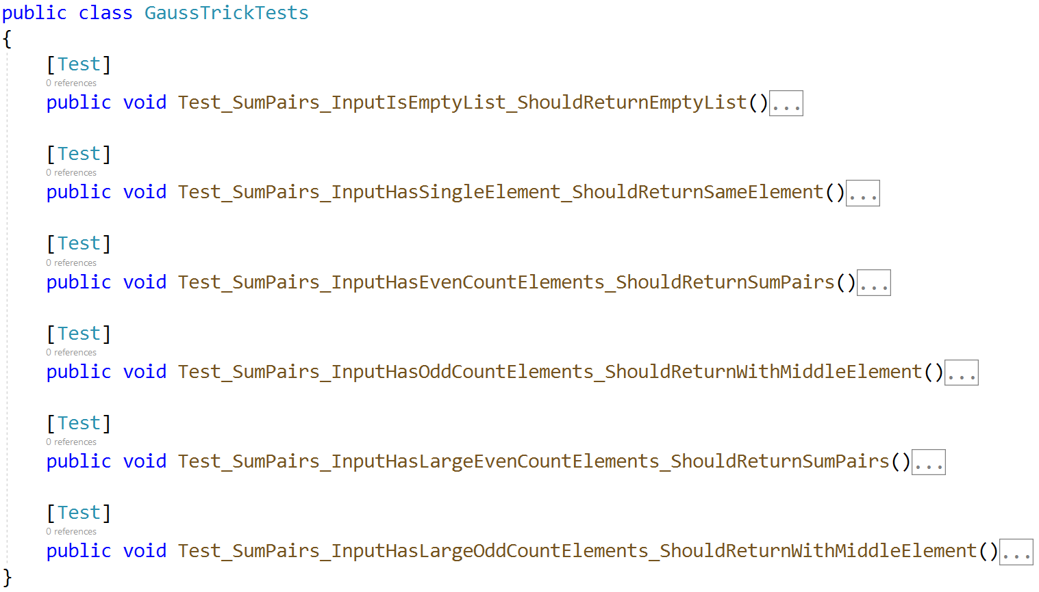
Hint: Use CollectionAssert to assert correctness when using lists. The first test is an example of it.
Don't forget to also assert if your tests run:
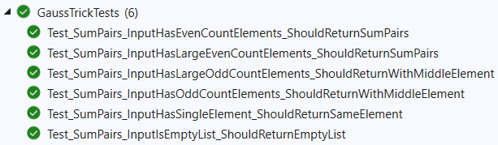

Unit Test List: Max Number
For the second list problem, test a method which takes in a list of integers and returns the largest number in the list.
The method is found in the MaxNumber.cs file:
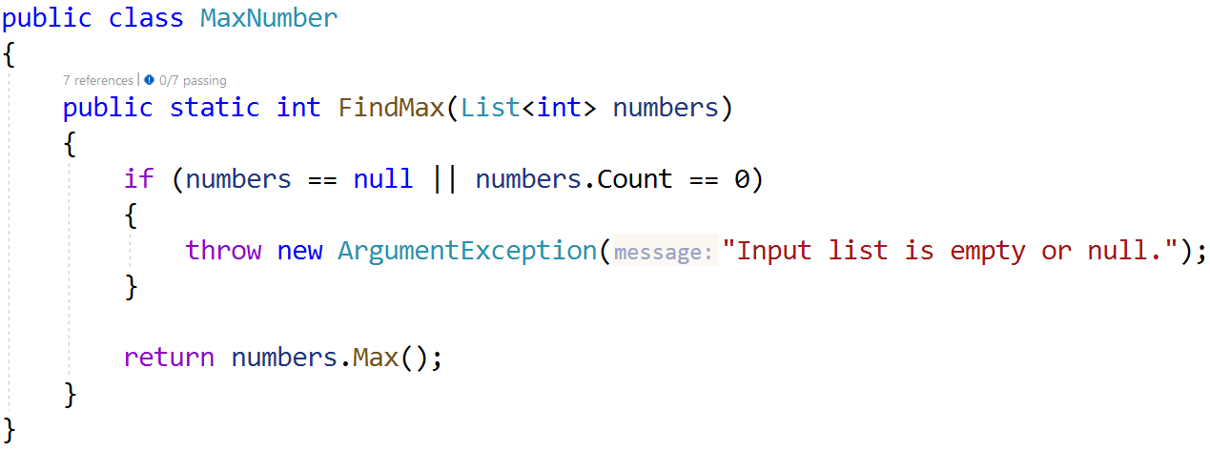
In the test file MaxNumberTests.cs you are given 5 tests:
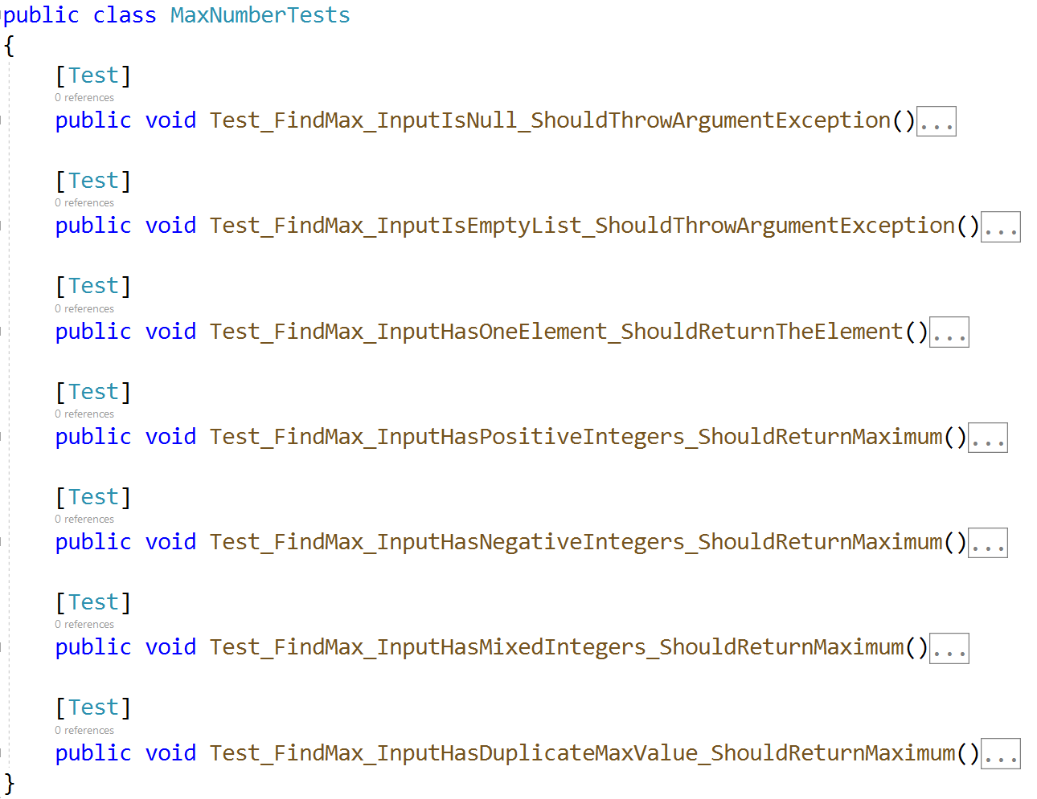
As usual check if your tests run correctly:
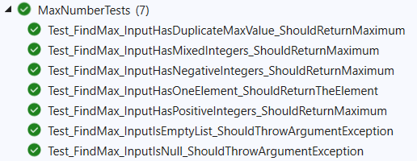

Unit Test List: Adjacent Equal
Test a method which takes in a list of integers and sums each adjacent number if they are equal and returns the list as a string.
The method is found in the AdjacentEqual.cs file:
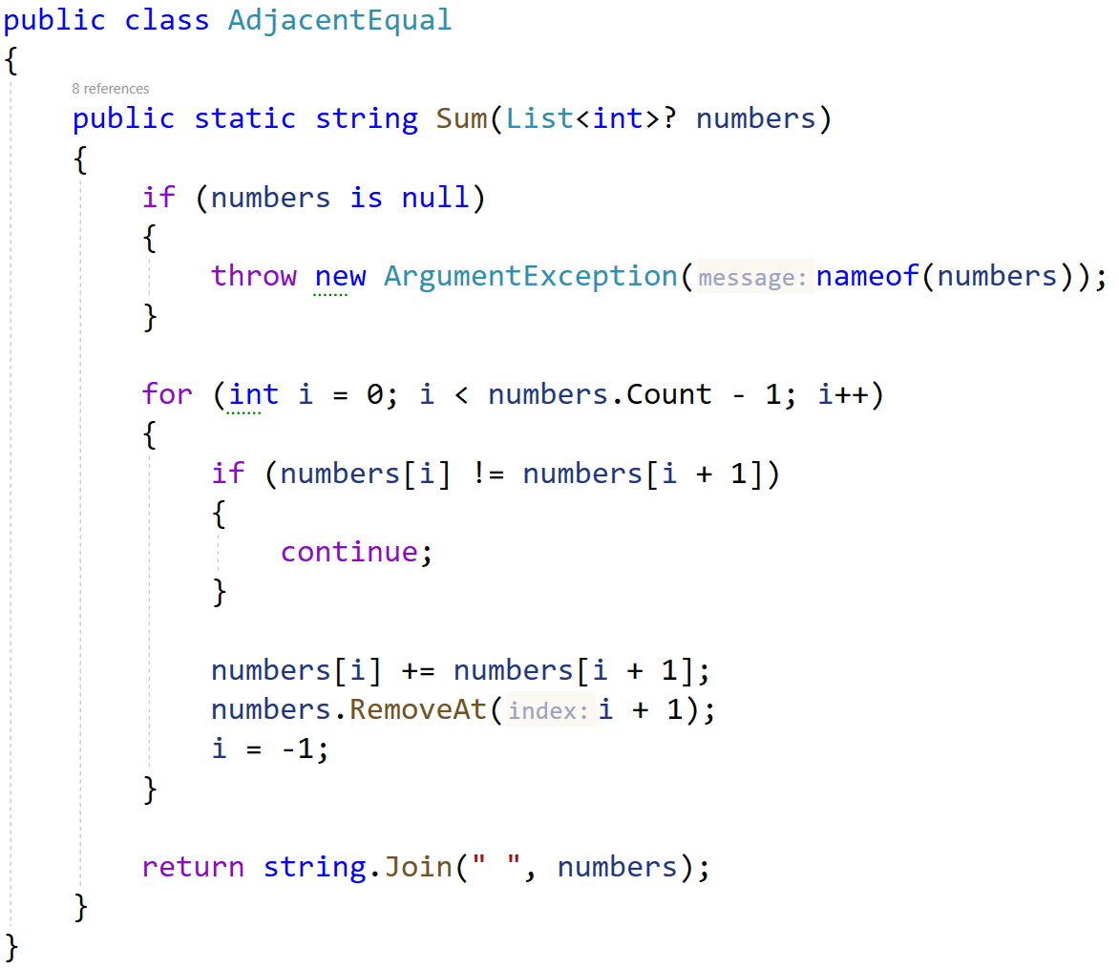
In the test file AdjacentEqualTests.cs you are given 7 tests:
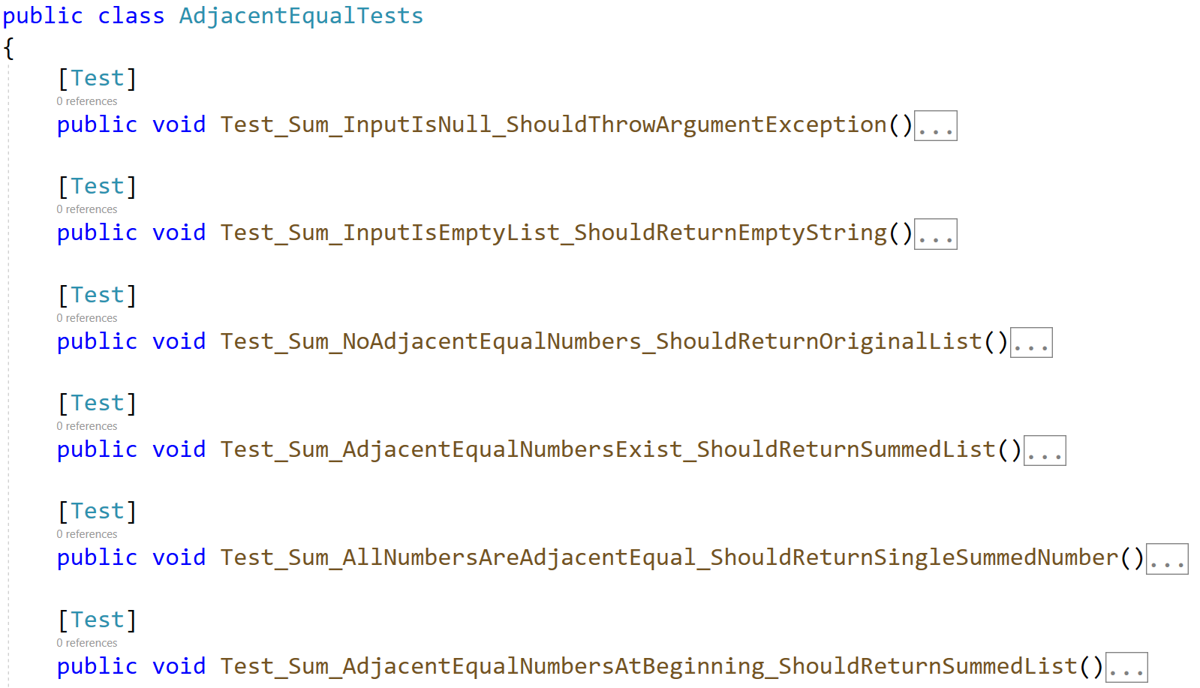
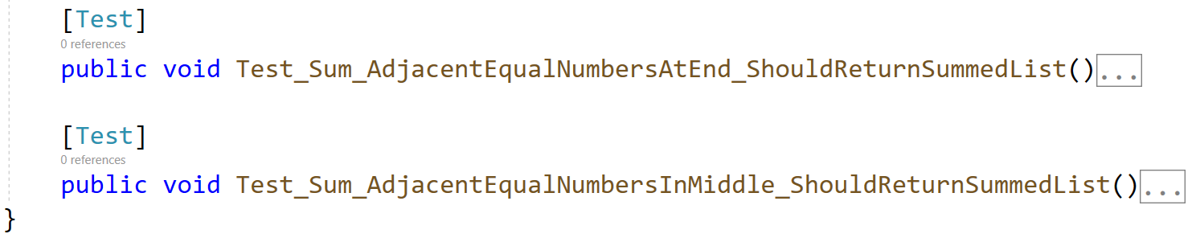
As usual check if your tests run correctly:
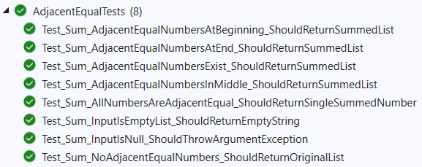

Unit Test List: List Analyzer
Test a given method which takes in a list of integers and returns string with information for elements number, mix, max and average values of the list in following format: "Element count: {list.length}, Min value: {list.Min()}, Max value: {list.Max()}, Avg: {list.Average():F2}."
The method is found in the ListAnalyzer.cs file:
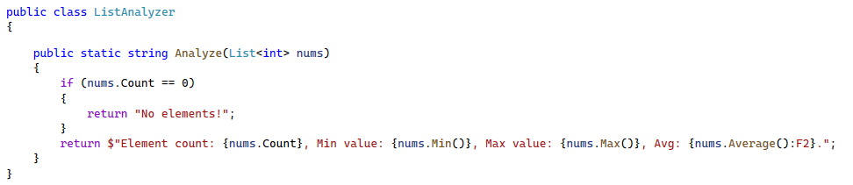
You are given a test file ListAnalyzerTests.cs containing 5 empty tests
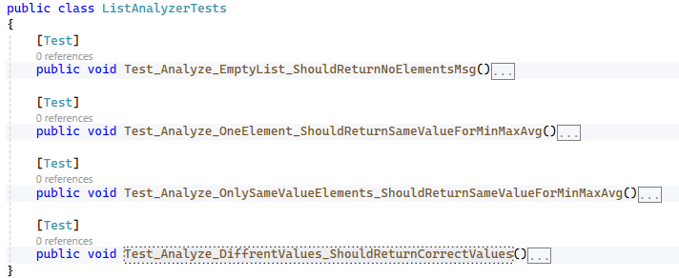
When you are ready make sure your tests run:
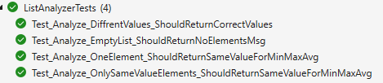

Unit Test List: Ignore The Chars
Test a given method that takes a string and a list of characters as input. The first parameter is a sentence, and the second parameter is a list of characters to ignore. The method returns the sentence without the ignored characters.
The method is found in the IgnoreTheChars.cs file:
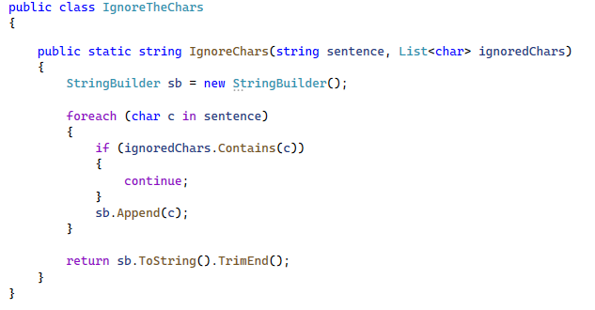
You are given a test file IgnoreTheCharsTests.cs containing 4 empty tests:
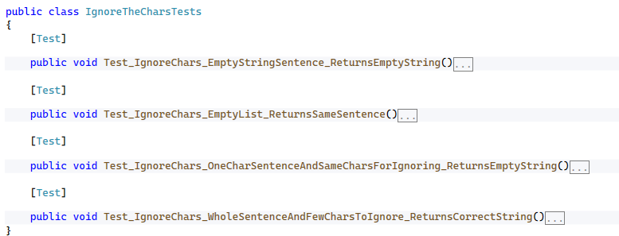
When you are ready make sure your tests run:
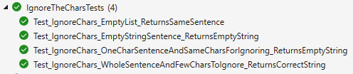

Unit Test List: Remove Negatives and Reverse
Test a given method that takes a list of integers, remove all negative numbers from it, reversed order and returns the result as a list.
The method is found in the ListManipulation.cs file:
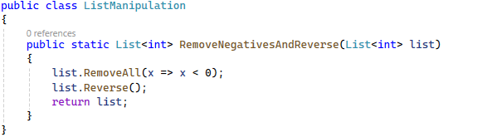
You are given a test file IgnoreTheCharsTests.cs containing 5 empty tests
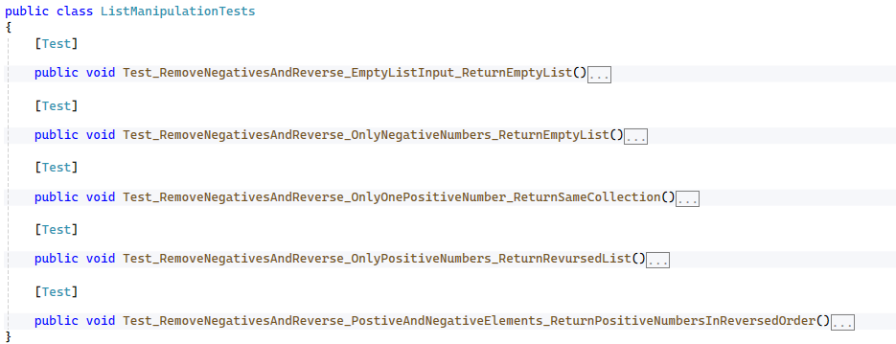
When you are ready make sure your tests run:
